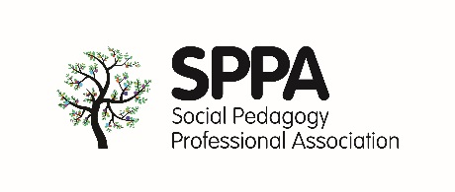
SPPA inaugural conference poster abstract submission form
Poster organisers/presenters (please include your full names, job titles, job occupations, work/university address):
Main contact:
Main contact email (we will use this email address for correspondence):
Main contact phone / mobile number:
Are you a SPPA founding member/s (If more than one in the group, please indicate who is a founding member)? Yes___ No___
Poster title:
(The title should be as brief as possible. Please capitalise only the first word, not each one. There should be no full stop at the end. Please do not use upper case for the title.)
Content:
The abstract is a short description of your work and should contain all the elements necessary to define your goals and introduce your results.
Abstracts should state, in 250 words or fewer, briefly and clearly, the following points:
• Aims/Objectives
• Content of Presentation
• Relevance/Impact
• Outcomes
• Discussion
Submission deadline
All abstracts need to be submitted by Friday 15th September 2017.
Notification
You will be notified about your poster abstract submission by Friday 22nd September 2017.

