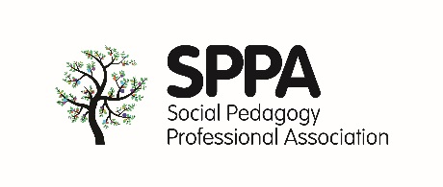
SPPA 2018 conference workshop proposal submission form
Workshop organisers/presenters (please include your full names, job titles, work/university address):
Main contact:
Main contact email (we will use this email address for correspondence):
Main contact phone / mobile number:
Are you a SPPA member/s (If more than one in the group, please indicate who is a member)? Yes ☐ No ☐
1. Workshop title
2. Who the workshop is for (target audience)?
3. Workshop description (250 words maximum)
4. Specific topics included?
5. Format of the workshop (You should aim to plan a workshop for 20-25 people which will run for a maximum of 1 hour 30 minutes. Whilst we aim to be able to offer you your ideal room layout as much as possible, there also needs to be some flexibility regarding this to accommodate the number of people that can fit in some of the rooms.)
6. Short biographies of the presenters (200 words maximum each)
7. Marketing and promotion (We will be marketing the conference including specific workshops leading up to the event. It will be really helpful to us if you are you able to plan and promote this workshop/ the SPPA conference through your own networks.)
8. If you’ve run this workshop previously (or a past version of it), please give us a brief description including level of engagement/impact, number of attendees etc.
Submission deadline
Please submit this to the SPPA Team by Friday 1st May 2018.
Notification
You will be notified regarding your workshop proposal by 31st May 2018.
Note on filming on photography
We will be taking photographs and potentially filming some sessions throughout the day and would like to seek your permission in doing so. If you would prefer your session to not be photographed / filmed, please let us know by emailing sppa@ucl.ac.uk.

